

**PRE BOARD EXAMINATION 2019 MARCH**

Bachelor Level/First Year/I Semester Full Marks: 50

Bachelor in Computer Application (BCA) Pass Marks:

Computer Fundamentals and Application (CACS101) Time: 2 Hr. 50 Min

Examination Date: 27th, Mar, 2019

*Candidates are required to give their answers in their own words as for as practicable.*

*The figures in the margin indicate full marks.*

**SET A**

**GROUP B**

**Attempt any SIX Questions:** **[6X5=30]**

1. Define computer. Explain the anatomy of digital computer with block diagram.
2. Define Software. List and explain the types of Software.
3. What is softcopy output device? Write down the working mechanism of hard disk.
4. Explain the different types of LAN topology with their advantages and disadvantages.
5. Define DBMS. Explain the different database models with their merits and demerits.
6. Differentiate between impact and non-impact printer.
7. Define Computer Network. Explain the different types LAN topologies with their advantages and disadvantages.

**Group C**

**Attempt any TWO Questions: [2X10=20]**

* 1. You are provided following data:  
     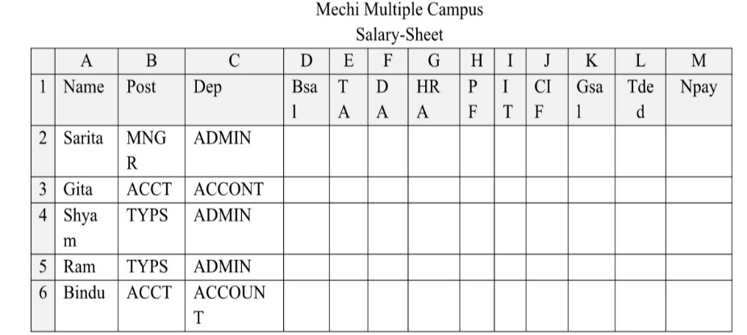  
     Write the formula in spreadsheet package to solve the following problems:  
     i. Calculate Bsal, 18000 for MNGR,15000 for ACCT and 14000 for TYPS [1]  
     ii. Calculate TA 20% of Bsal MNGR or ACCT [1]  
     iii. HRA 10% of Bsal for MNGR only. [.5]  
     iv. PF 20% of Bsal for TYPS or MNGR [1]  
     v. DA 5% of Bsal for all and IT 13% of Bsal if it Gsal is more than 20,000. [1]  
     vi. CIF 10% of Bsal if yearly income is less than 2,00,000. [1]  
     vii. Gsal=sum of Bsal,TA,DA,HRA [.5]  
     viii. Tded=Sum of PF,IT,CIF [.5]  
     ix. Npay=Difference of Gsal and Tded [.5]
  2. Differentiate between absolute and relative referencing in spreadsheet. [3]

1. Write down the importance of OSI model? Explain all the layers of OSI.
2. Describe computer virus. Illustrate the types of computer virus.